Best Practices of Crisis Management
A Step by Step Business Recovery Planner

Order Form (70081)


Best Practices Of  Crisis Management  $99.95 (70081) | Quantity | Total | Shipping/Handling  FREE! | Grand Total

Mail your completed order form along with payment to:
IIAA Education Department
127 South Peyton Street
Alexandria, VA 22314
Phone: (800) 261-4422

For faster service, fax your credit card order to:
(703) 683-7556

VUPoint
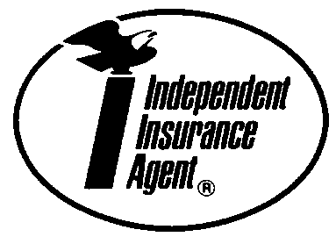
_____ Enclosed is my check made payable to IIAA

_____ Please bill my _____ MasterCard _____ Visa

Card #

Exp. Date

Name

Agency

Street

City

State Zip Code

Phone

Email

If your agency experiences a disaster you will have ONLY TWO choices to lead your agency out of the event.

You can choose the unprepared approach as do the vast majority of businesses OR choose the Best Practices of Crisis Management to lead you through the preparation of your business recovery plan. This valuable tool includes both a written guide and an interactive CD designed to enable you to create an in-house, fully customized plan to lead your agency step-by-step through the recovery process.

A good business recovery plan can:
- Reduce the amount of a business interruption claim
- Reduce the number of days it takes to reorganize an agency after a loss
- Ease the emotional trauma for your customers and the companies you represent
- Give your organization a step-by–step plan that will help them manage the disruption to business
Other services via phone and online included:
- Project Management to help your internal team finish the plan in a reasonable timeframe
- Business Analysts on call to lead the project inside your company
System requirements:
- Windows 95/98
- Word 6.0
- Word 97/2000 (recommended)

